Business Requirements

Program Name: | C-TPAT | Program Manager:
Project Name: | C-TPAT On VSA and VMA | Project Manager: | David Shapiro
Project Number: |  | Account Unit:
Sponsor: |  | Business Owner:

Document Version Control
Date | Version # | Describe Revision(s) | Author(s)
05/20/2011 | 1.0 | Initial version | Cognizant
07/12/2011 | 1.1 | Review Comments Incorporated | Cognizant
07/21/2011 | 1.2 | Incorporated Business Comments | Cognizant
07/27/2011 | 1.3 | Incorporated the comments as per the discussion with David | Cognizant
07/28/2011 | 1.4 | Admin tool requirement has been changed | Cognizant
08/08/2011 | 1.5 | Updated MSR creating Vendors, Alert and Existing Vendors requirement as per the meeting with Business | Cognizant

Table of Contents
1 Document Overview 4
1.1 Business Objectives 4
1.2 Business Benefits 4
1.3 In Scope 4
1.3.1 C-TPAT Vendor Preliminary Questionnaire - VSA 4
1.3.2 C-TPAT Vendor Detailed Questionnaire- Vendor View -VSA 4
1.3.3 C-TPAT Vendor Detailed Questionnaire- Authorized Corporate Users View -VSA 4
1.3.4 MSR Creating Vendors – VSA. 5
1.3.5 CM Review - VSA 5
1.3.6 MSR Review - VSA 5
1.3.7 Yearly Reminder 5
1.3.8 Questionnaire Update on VMA – Vendor View 5
1.3.9 Questionnaire Review on VMA – Authorized Corporate Users View 6
1.3.10 Existing Vendors 6
1.3.11 Admin tool for Authorized Corporate Users. 6
2 Process Flow 8
3 Screenshots. 9
3.1 C-TPAT Preliminary Questions For Vendor 9
3.2 C-TPAT Preliminary Question 10
3.3 CTPAT Detailed Questionnaire Link 11
3.4 C-TPAT Detailed Questionnaire for Vendors 12
3.5 Authorized Corporate Users View 13
3.6 Authorized Corporate Users Review 14
3.7 Authorized Corporate Users Review –Reject option 14
3.8 Complinace Group Review the Certificate 15
3.9 CM View the C-TPAT Status 16
3.10 MSR View the C-TPAT Status after Authorized Corporate Users review 17
3.11 Admin Screen – Import Excel Link 18
3.12 Admin Screen – Import Excel Page 18
3.13 Admin Preview the Questions 19
4 Sample Excel 19
5 Assumptions 19
6 Dependencies 19
7 Integration with other systems 20
7.1 Changes in Other Applications 20
7.2 Non Functional Requirements 20
7.3 Performance 20
7.4 Scalability 20
7.5 Availability 20

Document Overview

This document covers business requirements for implementing C-TPAT enhancement in Vendor Setup Application. A new functionality will be provided in Vendor Setup Application to allow import vendors to fill up C-TPAT questionnaire

Business Objectives

- Providing an online access for Import Vendors to fill up C-TPAT Questionnaire
- New review / approval queue will be built in Vendor Setup Application Authorized Corporate Users to review C-TPAT Questionnaire provided by the vendor.

Business Benefits
- Import vendor C-TPAT standard will be assessed.

In Scope

C-TPAT Vendor Preliminary Questionnaire - VSA

- Import Vendors has to select whether they are C-TPAT Certified or not as part of Preliminary Questions.
- If the import Vendor owns a C-TPAT Certificate, then there is an option should be provided to enter the certificate number and the Expiration Date
- This option should not be provided ,if the vendor selects ‘No’
- After receiving the certificate number and the Expiration date an Email notification will be sent to Customs Authorized Corporate Users for verification of C-TPAT certification.

C-TPAT Vendor Detailed Questionnaire- Vendor View -VSA

- If Vendor selected ‘No’ in the preliminary questions and he does not have valid certificate number, then the system will display the detailed C-TPAT questionnaire along with detail questionnaire
- After the C-TPAT Questionnaire is completed by respective import vendor, a notification email will be sent to Authorized Corporate Users.
- Email should have direct link to the review page and also link to the Vendor’s list page.

C-TPAT Vendor Detailed Questionnaire- Authorized Corporate Users View -VSA

- When they click on the link in the email, Authorized Corporate Users can only view the C-TPAT Questionnaire page or the Certificate Details.
- Authorized Corporate Users can view the status of the vendor by logging to the application page also.
- When they login, page should have list of Import Vendor and Vendor’s Questionnaire/Certificate status.
- Status can have either as ‘Progress’ or ‘Completed’
- Authorized Corporate Users should view the Answers in a grouped manner. Answers which are C-TPAT compliant should be displayed in the top and the answers which are not compliant with C-TPAT should be displayed next.
- New function to be added in Authenticator to give access to corporate users.
- Answers which need to be reviewed manually by the Authorized Corporate Users should be displayed in the bottom.
- If the Questions are outdated (previous version), those questions should be differentiated.
- There is a ‘Check Box’ should be provided with the text “I want to reject’’ and there should be a ‘Approve’ or ‘Reject’ button .
- If the user selects the checkbox, then there is a text areas should be enabled to enter the reason. ‘Approve’ button should be disabled.
- If the user does not select the ‘Approve’ button, ‘Reject’ button should be disabled.
- If Authorized Corporate Users is rejecting, an email should have been sent to the Vendor, Category Manager and MSR along with the reason.
- All the answers provided by the user are valid for one year from the submitted date.
- Certificate number is valid only till the Expiration Date.

MSR Creating Vendors – VSA
- When the MSR creates the vendor in VSA, there should be a question to be asked whether C-TAPT details should be asked or not.
- If MSR selects ‘yes’ then, there should be an option to ask for the C-TPAT Certificate. If Vendor doesn’t have C-TPAT Certificate number, C-TPAT Questionnaire to be displayed.
- If MSR selects ‘No’, then there should not be an option to ask either C-TPAT certificate details or C-TAPT Questionnaire.

CM Review - VSA

- CM should able to view the C-TPAT Compliance Status either In Progress or Approved or Rejected of the Import Vendor in his queue irrespective of Authorized Corporate Users approval /rejection.

MSR Review - VSA

- MSR should able to view the C-TPAT Compliance Status (Approved or Rejected by Authorized Corporate Users) of the Import Vendor in his queue after CM approves the Vendor.

Yearly Reminder

- C-TPAT Questionnaire validity expires within one year from the date submitted.
- C-TPAT Certificate expires after the expiration date.
- Weekly batch job has to monitor the C-TPAT Questionnaire and Certificate status of the Vendors.
- Reminder emails has to be sent to the Vendor about Expiration date to fill the questionnaire or to enter the certificate
- No of Reminder emails and the frequency should be configurable.
- Email will be sent to the Vendor with the link to C-TPAT pages.
- Alert should display for the Vendors to remind about the C-TPAT expiry in the application. Existing alert framework should be used.

Questionnaire Update on VMA – Vendor View
- When the user clicks on the link, user will be asked to enter the certificate number. If the user does not have certificate number, user will be asked to enter the C-TPAT Questionnaire.
- If the user has certificate number, there should be an option to enter the certificate number and Expiry date. These pages should be part of VMA.
- An email will be sent to the Authorized Corporate Users after Vendor submitted answers.

Questionnaire Review on VMA – Authorized Corporate Users View
- When the user clicks on the link in the email, they will able to see the C-TPAT answers in non-editable mode. This link should be part of VMA application.
- Authorized Corporate Users can view the status by logging into the application. They will able to see the Vendor Name and the C-TPAT answer status ‘Progress’, ‘Completed’ and ‘Expected’. Users who saved and not submitted the answers , will be shown as ‘Progress’ and Users who have completed all the answers will be shown as ‘Completed’ and Users who C-TPAT status is expiring and expected to complete the answer within some configurable duration will be displayed as ‘Expected’ (exact status wordings will be decided later).
- Authorized Corporate Users should view the Answers in a grouped manner. Answers which are C-TPAT compliant should be displayed in the top and the answers which are not compliant with C-TPAT should be displayed next. Answers which need to be reviewed manually by the Authorized Corporate Users should be displayed in the bottom.
- There is a ‘Check Box’ should be provided with the text “I want to reject’’ and there should be a ‘Approve’ or ‘Reject’ button .
- If the user selects the checkbox, then there is a text areas should be enabled to enter the reason. ‘Approve’ button should be disabled.
- If the user does not select the ‘Approve’ button, ‘Reject’ button should be disabled.
- If Authorized Corporate Users is not agreeing, an email should have been sent to the Vendor, Category Manager and MSR along with the reason.
- Yearly review will be done ONLY by authorized corporate users.

Existing Vendors - VMA
- All the existing Vendors who doesn’t have certificate number or have not answered for the C-TPAT Questionnaire should be notified to enter either the Certificate number or the C-TPAT Questionnaire. Screen for entering the C-TPAT Questionnaire and Certificate number should be same as yearly review.
- After vendor submits the answer, email will be triggered to Authorized Corporate Users.
- Authorized Corporate Users will either approve /reject based on the answers. This is same as the yearly review .

Admin tool for Authorized Corporate Users.

- There should be admin screen provided to Import/Export the C-TPAT questionnaires.
- There should be formatted excel which should capture all the Questions and Question’s fields.
- Each Question should have the following field
  - Question
  - Answer Type
  - Compliance Answer
  - Mandatory or Not
- Question – Admin can enter the question.
- Answer Type - Answer Type can be the following, All the answer should have ‘Other’ Category
  - ‘Yes’ or ‘No’ or ‘Other’.
  - Multiple Choice – If the admin selects multiple choices, there should be an option to provide all the values.
  - Scale - If the admin selects ‘Scale’ there should be an option to enter the no of scales and details.
- Every Question should have text area to enter comment.
- Compliance Answer – Admin needs to provide the answer which is adhere to C-TPAT.
- After importing, there should be an option to view the Questions as is in Vendor’s Detailed Questionnaire.
- This page should be accessible only to Authorized Corporate Users.
- Training document should be created for the business user to explain about excel.

Process Flow
=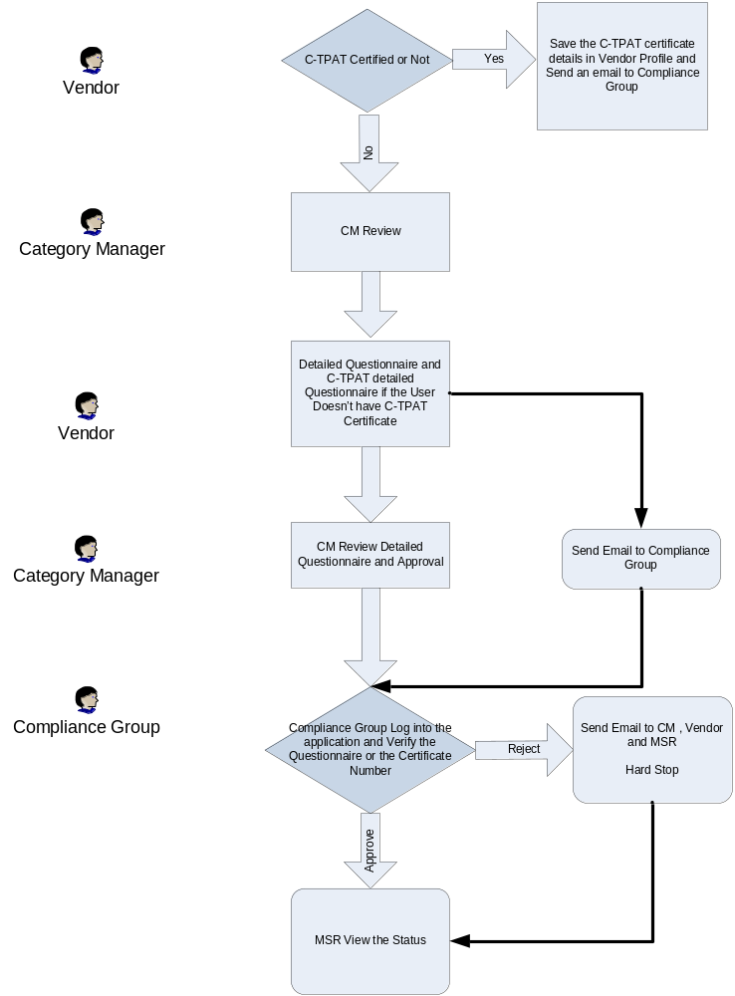

Screenshots.

C-TPAT Preliminary Questions For Vendor

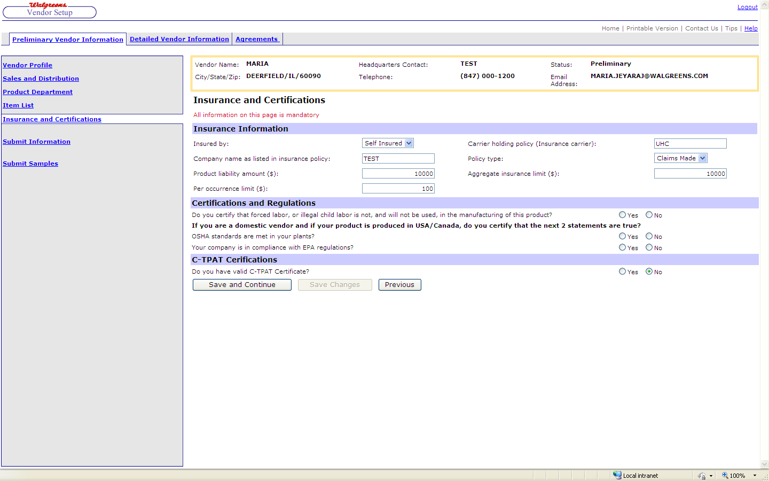

C-TPAT Preliminary Question
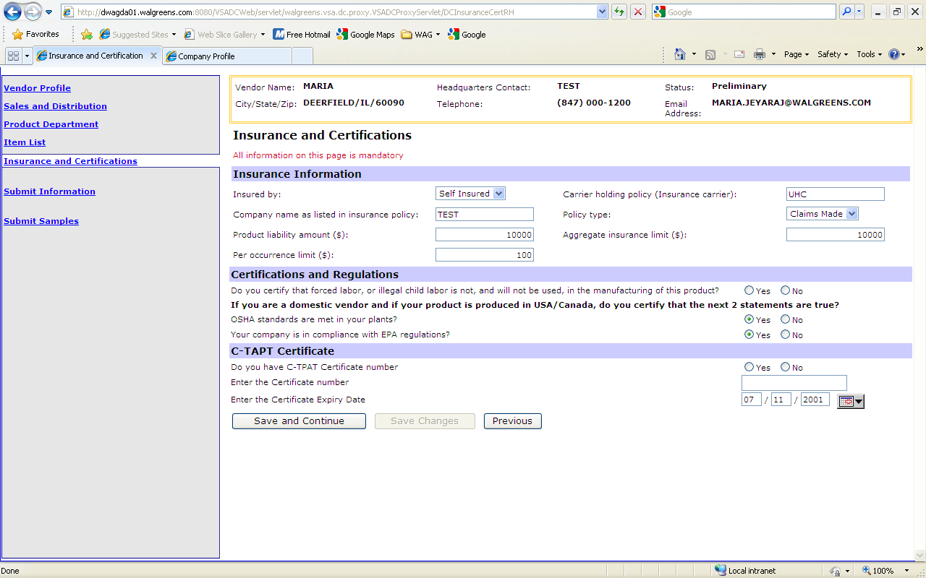

CTPAT Detailed Questionnaire Link
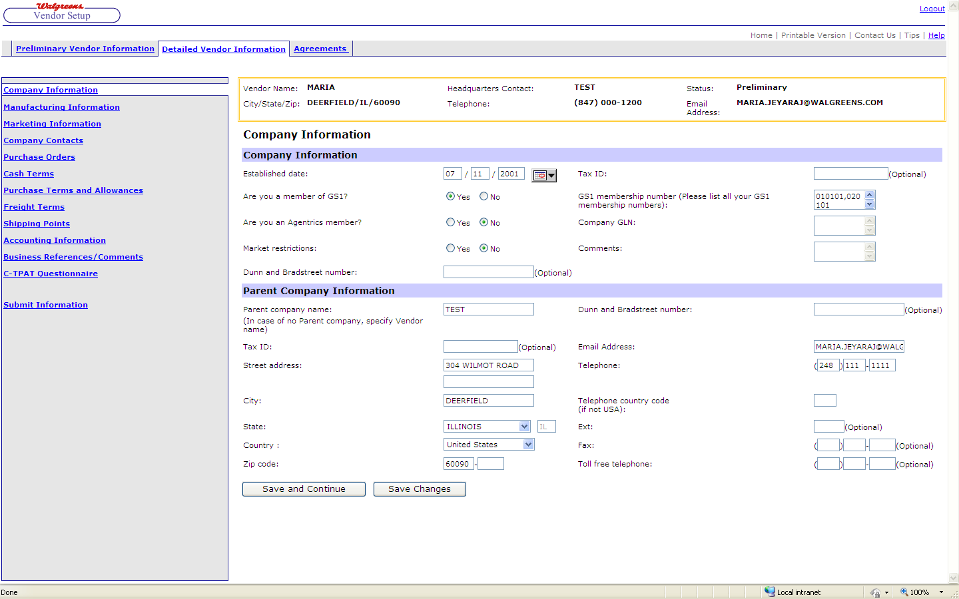

C-TPAT Detailed Questionnaire for Vendors

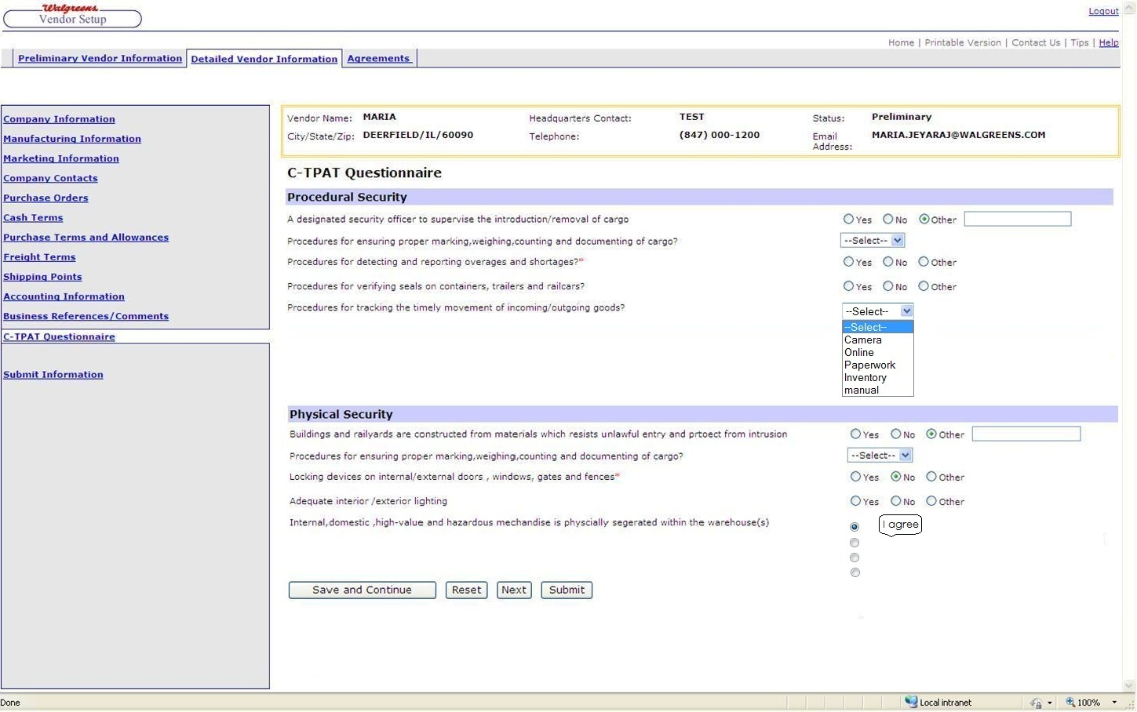

Authorized Corporate Users View
Authorized Corporate Users view the entire Vendor’s who completed the C-TAPT Questionnaire and the Vendors who are answered and not submitted

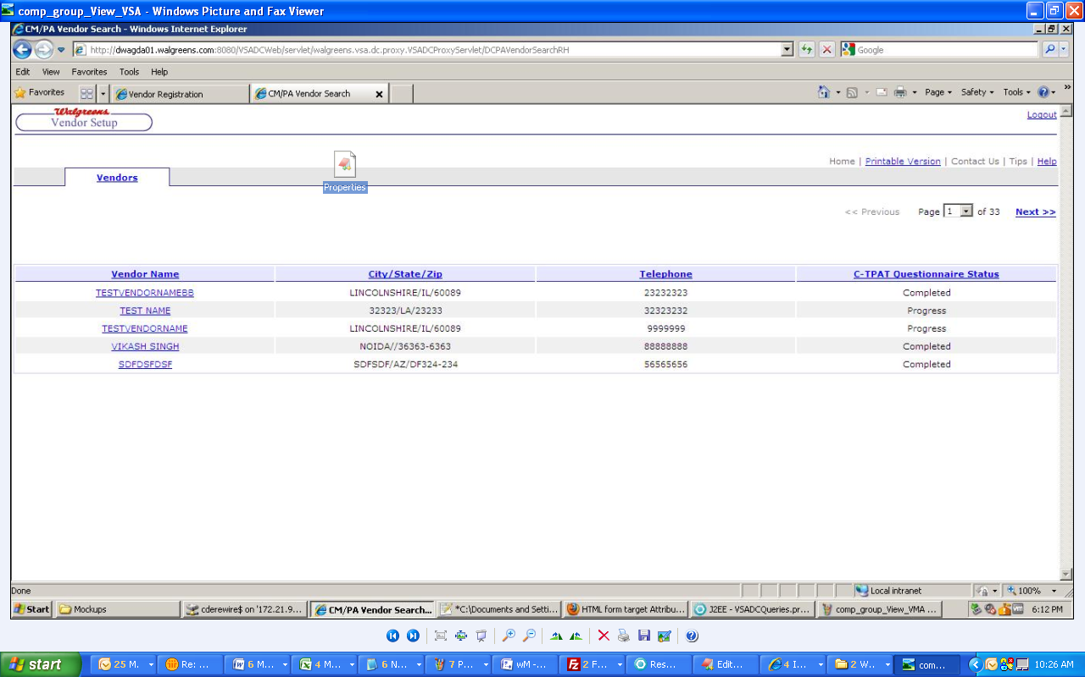

Authorized Corporate Users Review
Authorized Corporate Users view the Vendor’s C-TPAT Questionnaire Page when he clicks the link directly from email or can navigate to this page thru the page which is screenshot No.4

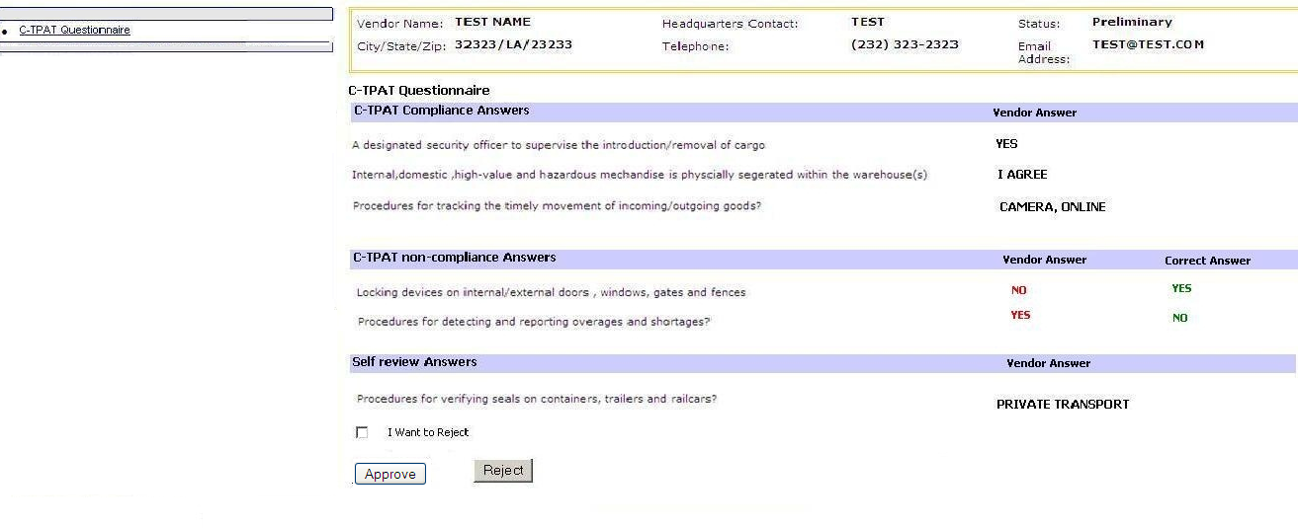

Authorized Corporate Users Review –Reject option

If the user clicks on ‘I want to reject’ text box will be displayed to enter the reason
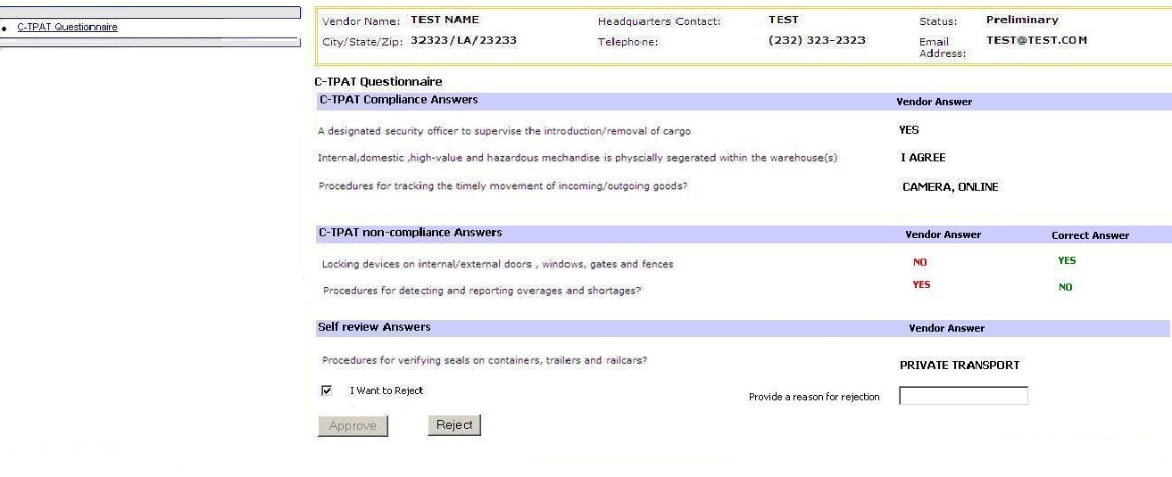

Complinace Group Review the Certificate
This page will be displayed for the Authorized Corporate Users when he clicks the link in the email (If vendor has entered certificate number
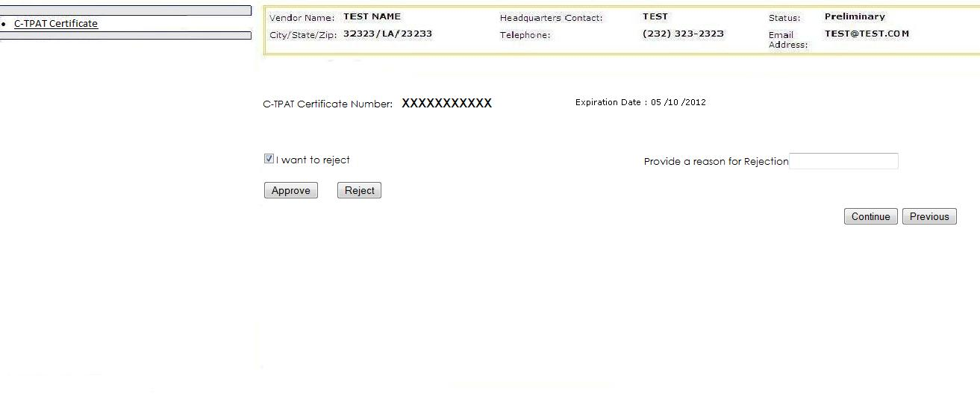

CM View the C-TPAT Status
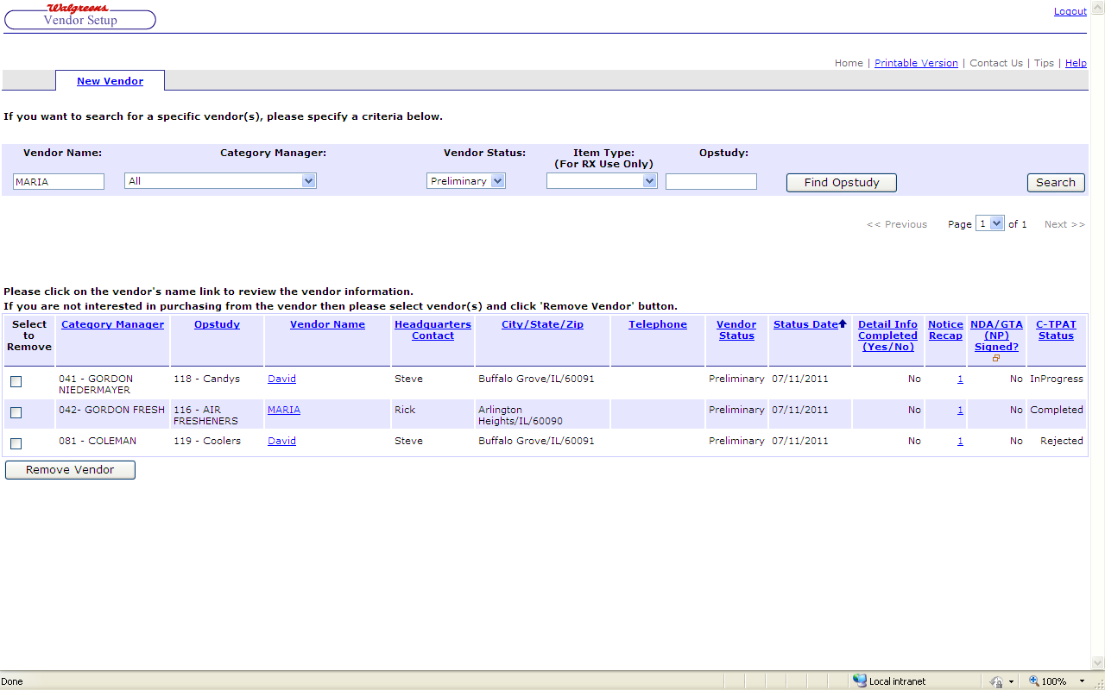

MSR View the C-TPAT Status after Authorized Corporate Users review

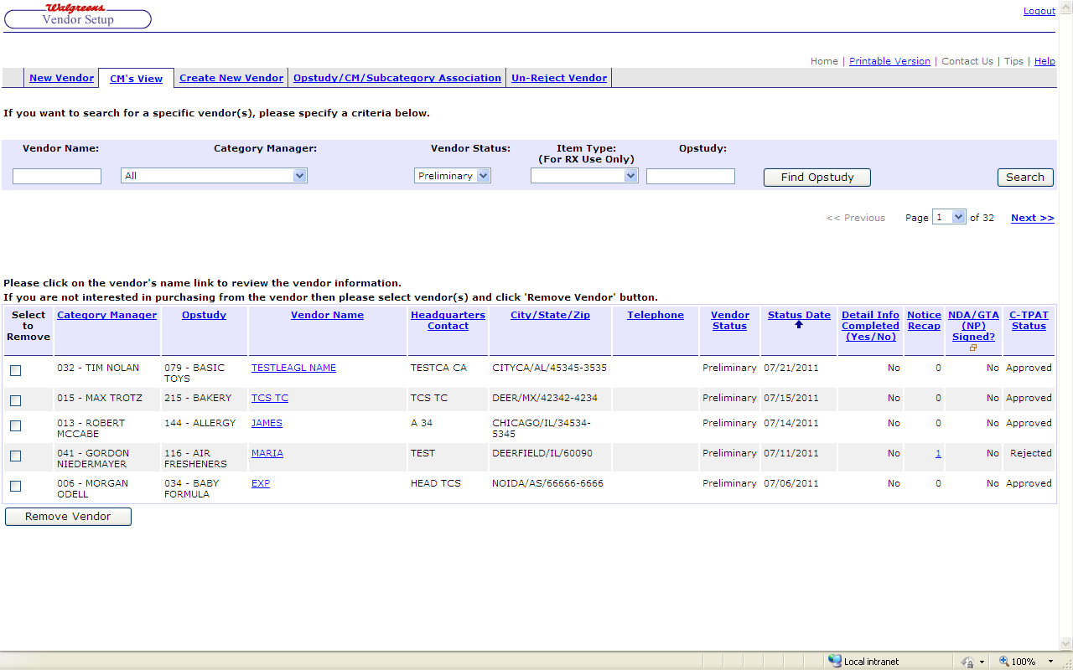

Admin Screen – Import Excel Link

Admin can import the master Questionnaire, answers and the question type thru formatted excel sheet.

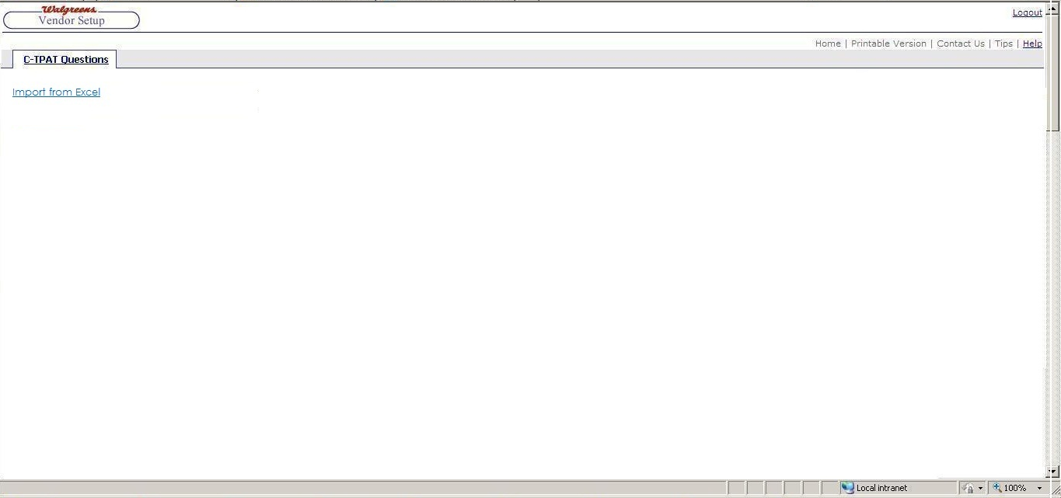

Admin Screen – Import Excel Page

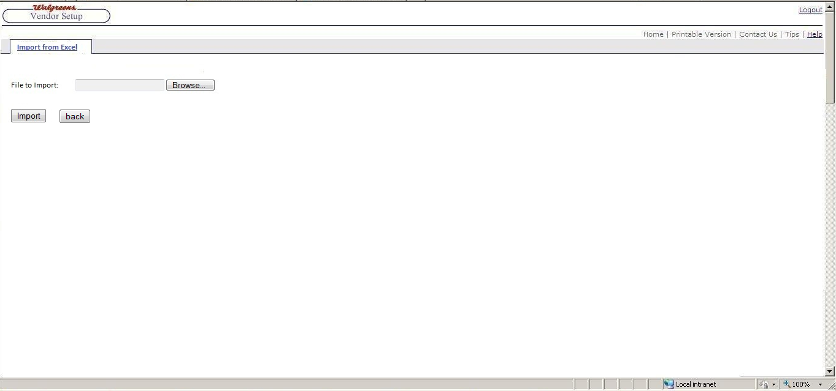

Admin Preview the Questions

(on clicking the Import link an excel sheet will open with the set of questions currently in the database). Admin can export the displayed questions to an Excel.
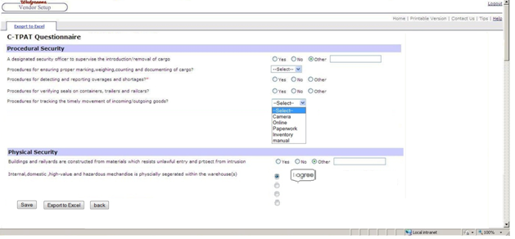

Sample Excel
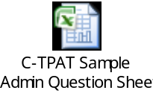

Assumptions
- There is no change in the existing approval workflow in VSA
- We are not modifying any VMA workflow.
- There is no dependency between each question.
- When the admin starts importing the Questions, if any of the Vendors is already started answering for the Current Questions, he should able to work on his own copy of the old Questions.
- Admin Excel will be finalized during the design phase
- All the screens, fields, contents and email contents will be finalized during design phase.

Dependencies

Integration with other systems

Changes in Other Applications
NA

Non Functional Requirements
NA

Performance

Scalability

Availability

